**Project Management**

1. 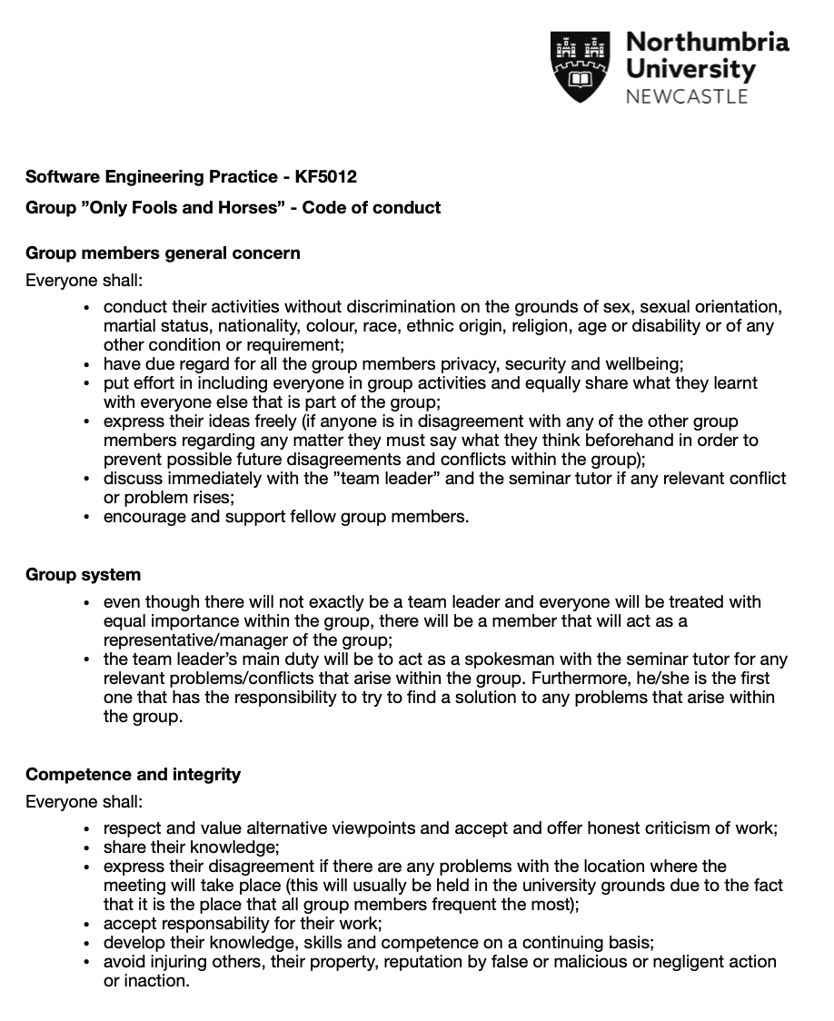**Code of Conduct**

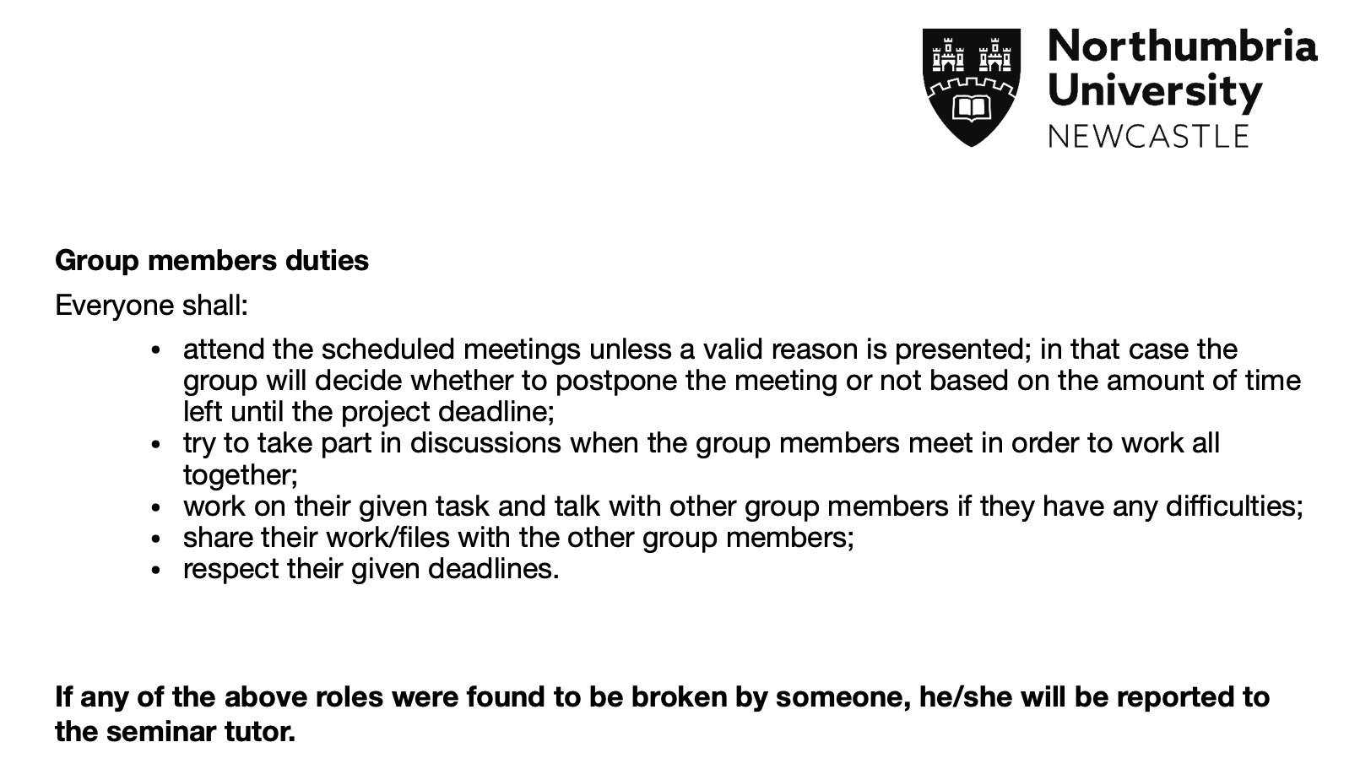

1. **Skills Audits**

* Justyna Wachowiak

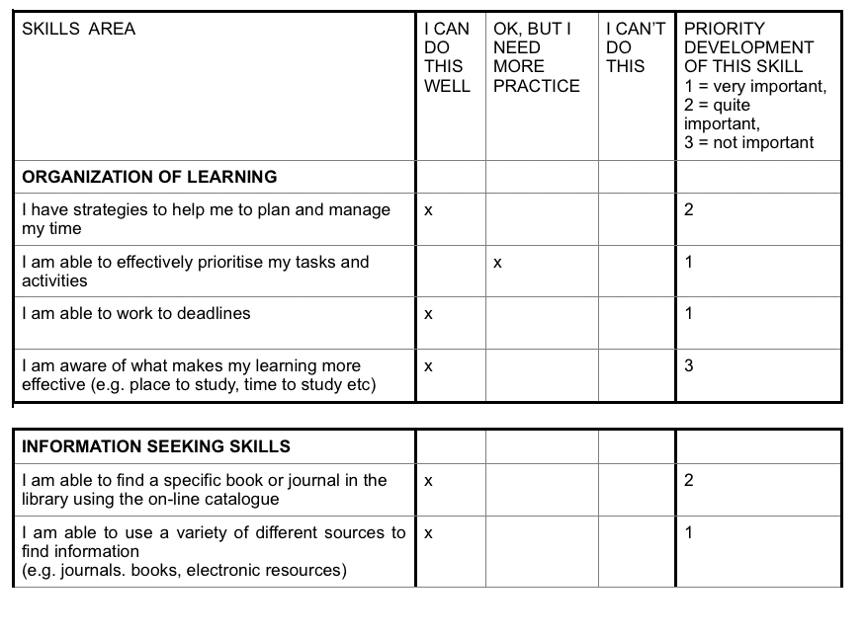**PART 1**

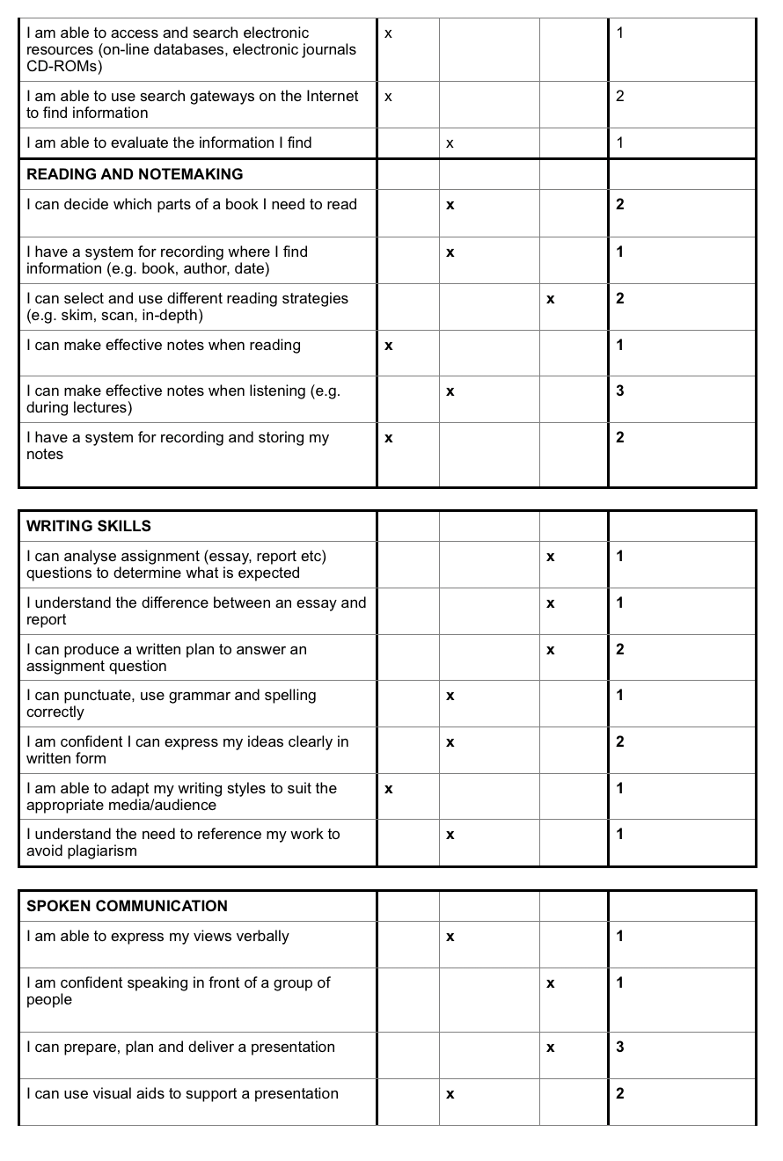

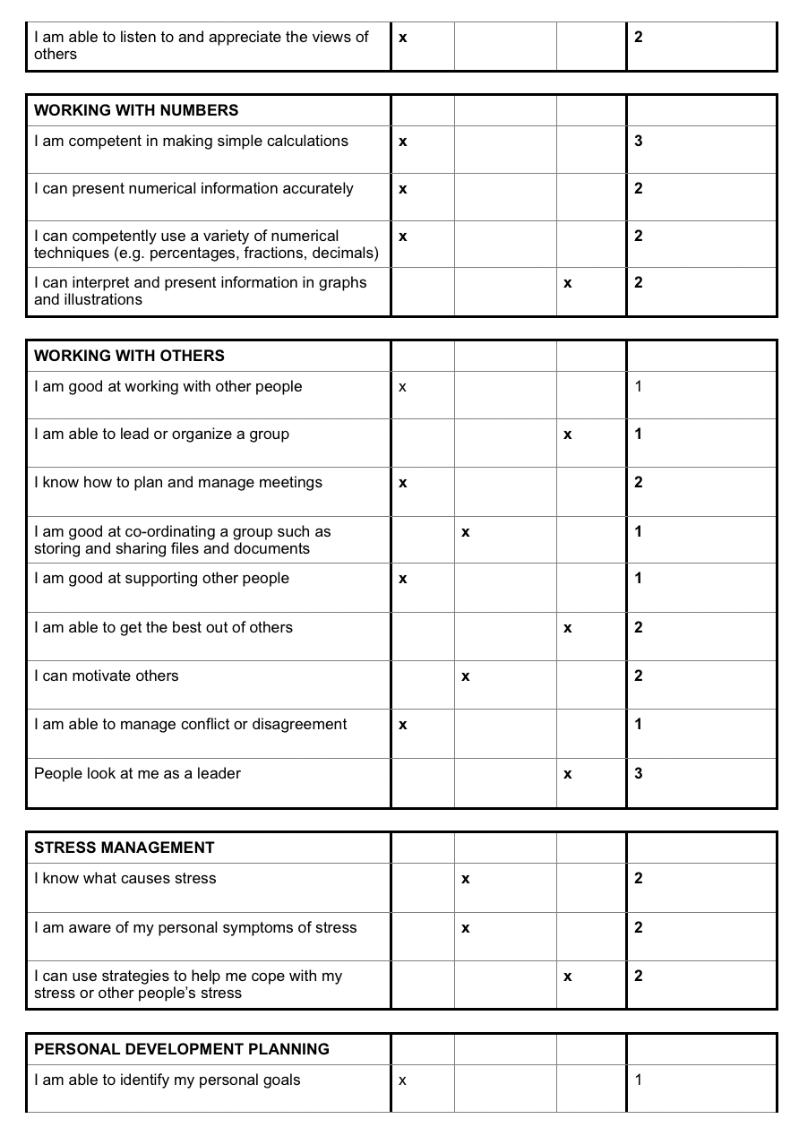

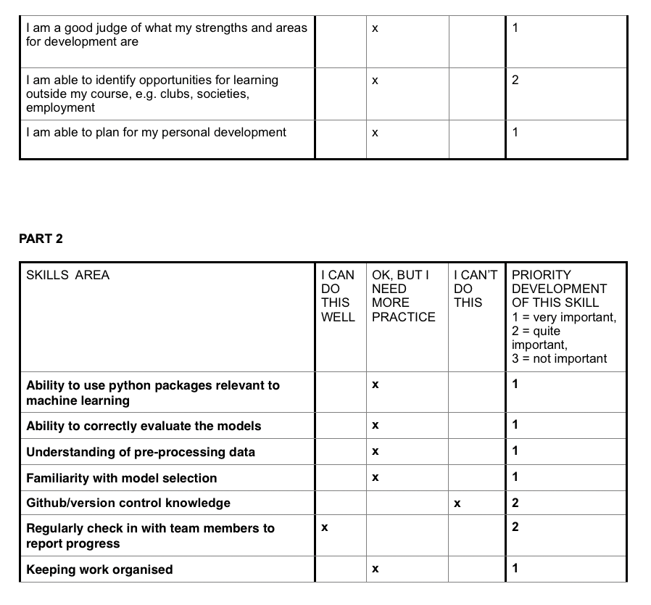

* Christopher Graney-Ward

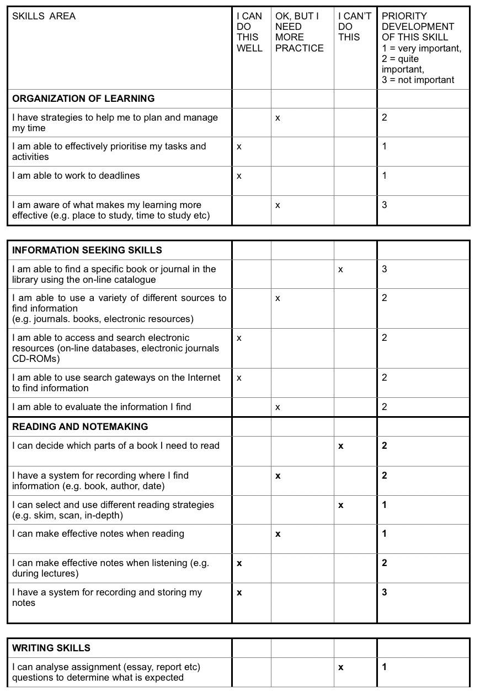**PART 1**

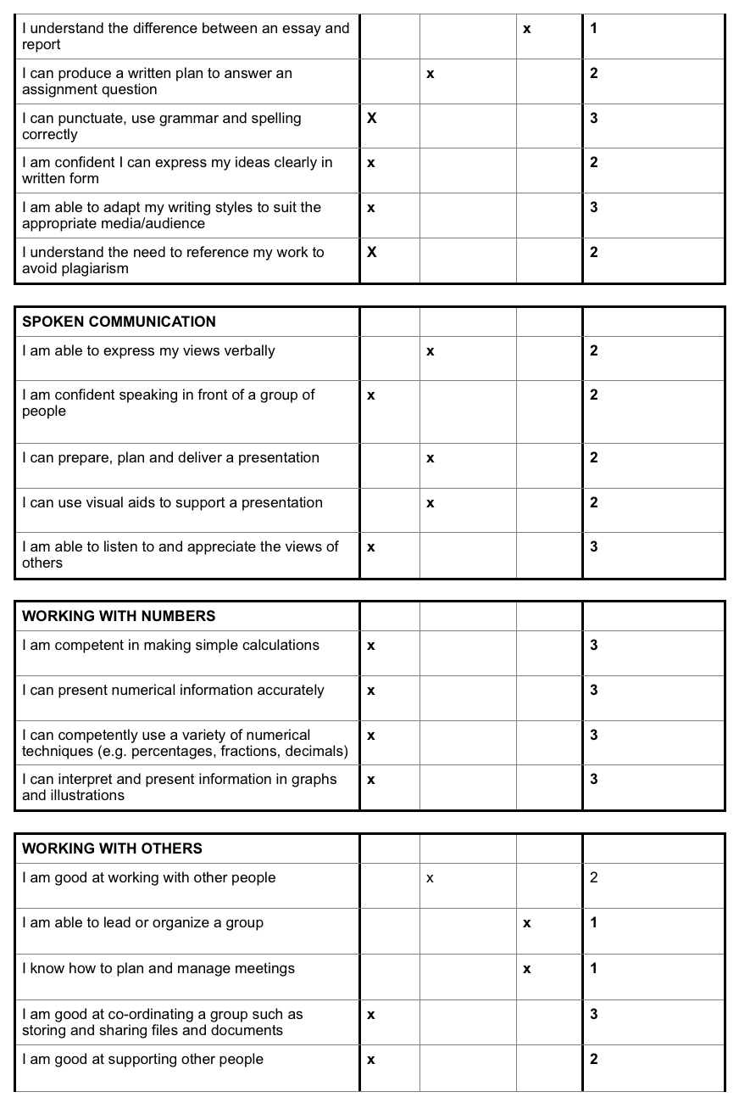

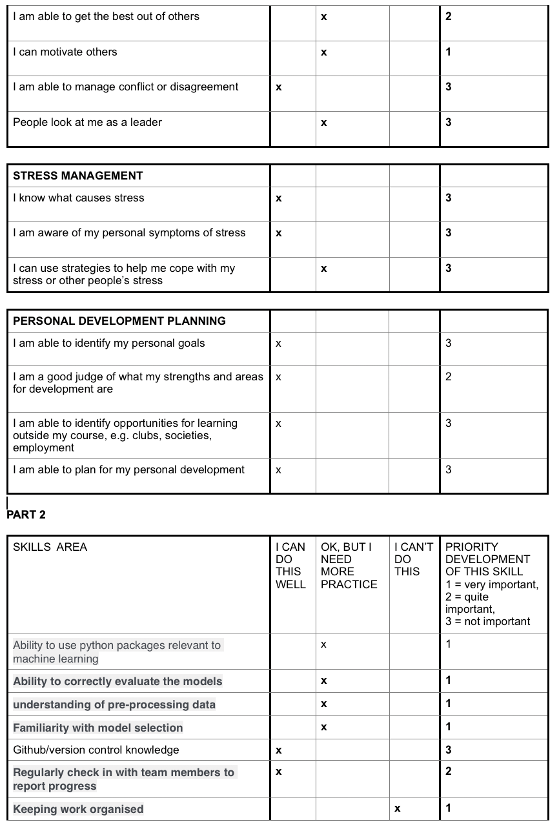

* 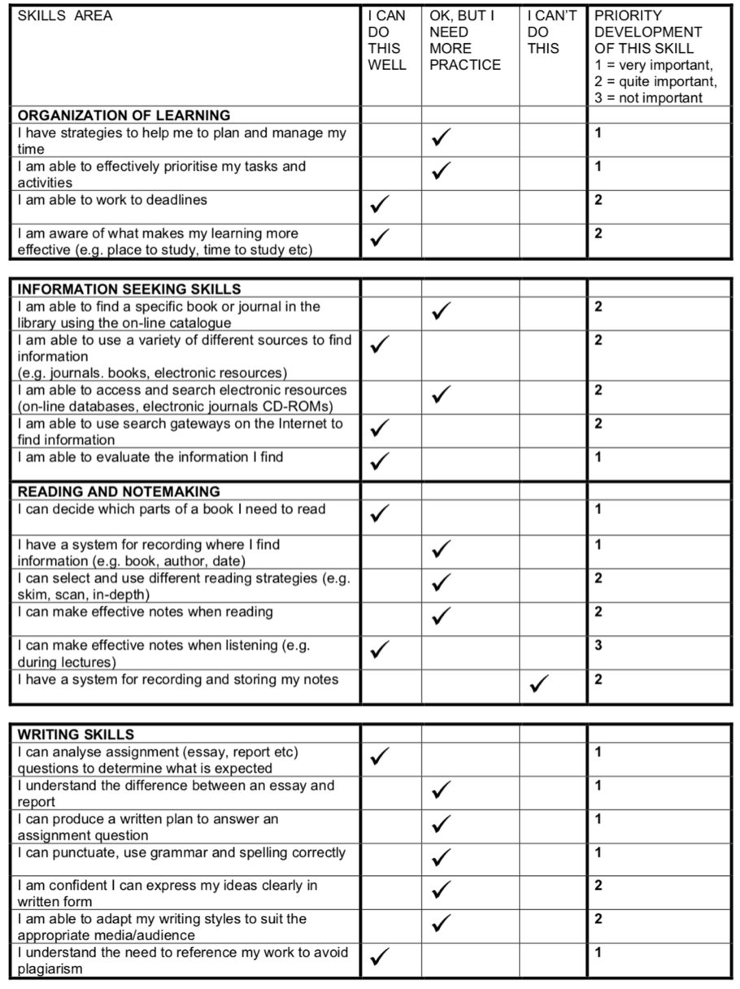Michael Anderson

**PART 1**

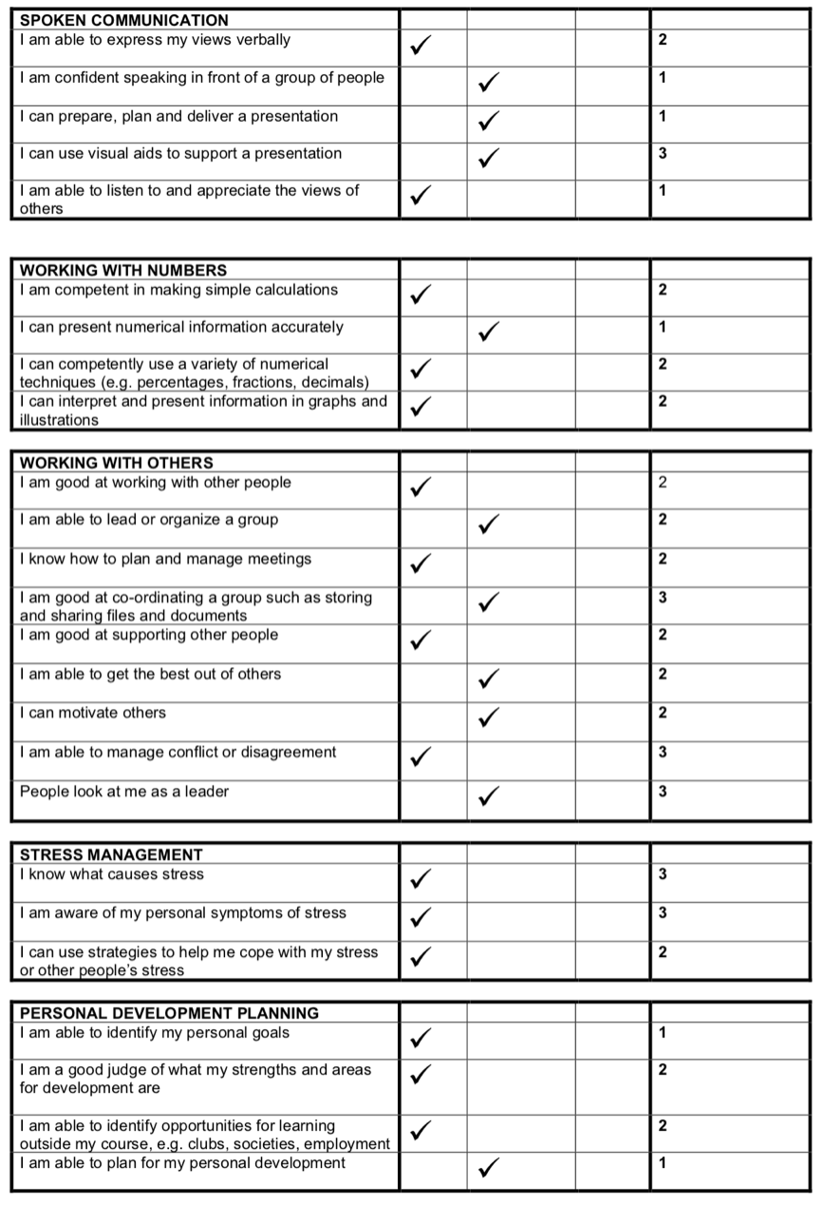

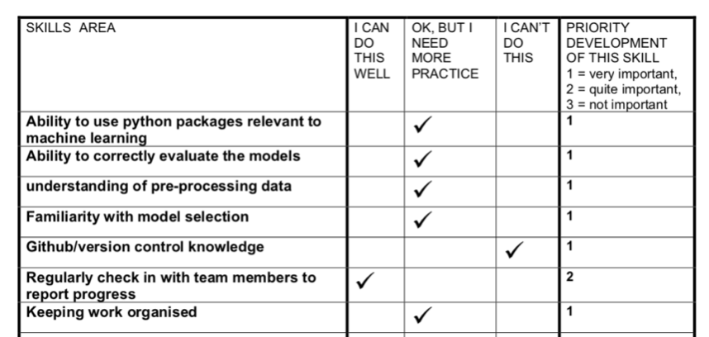**PART 2**

* Radek Jirkovsky

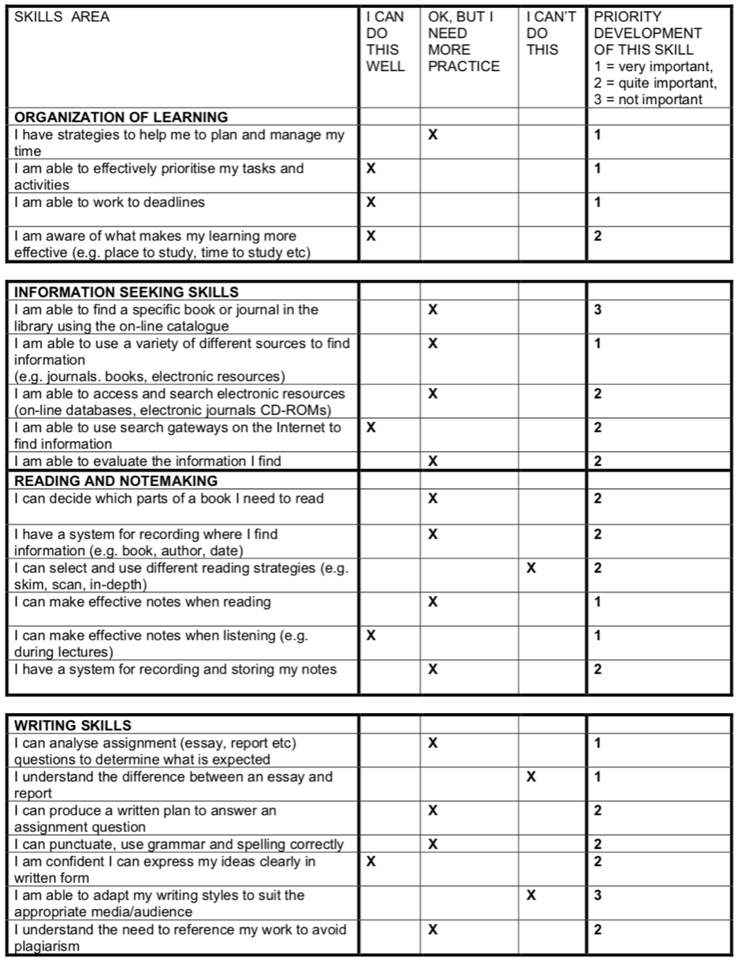**PART 1**

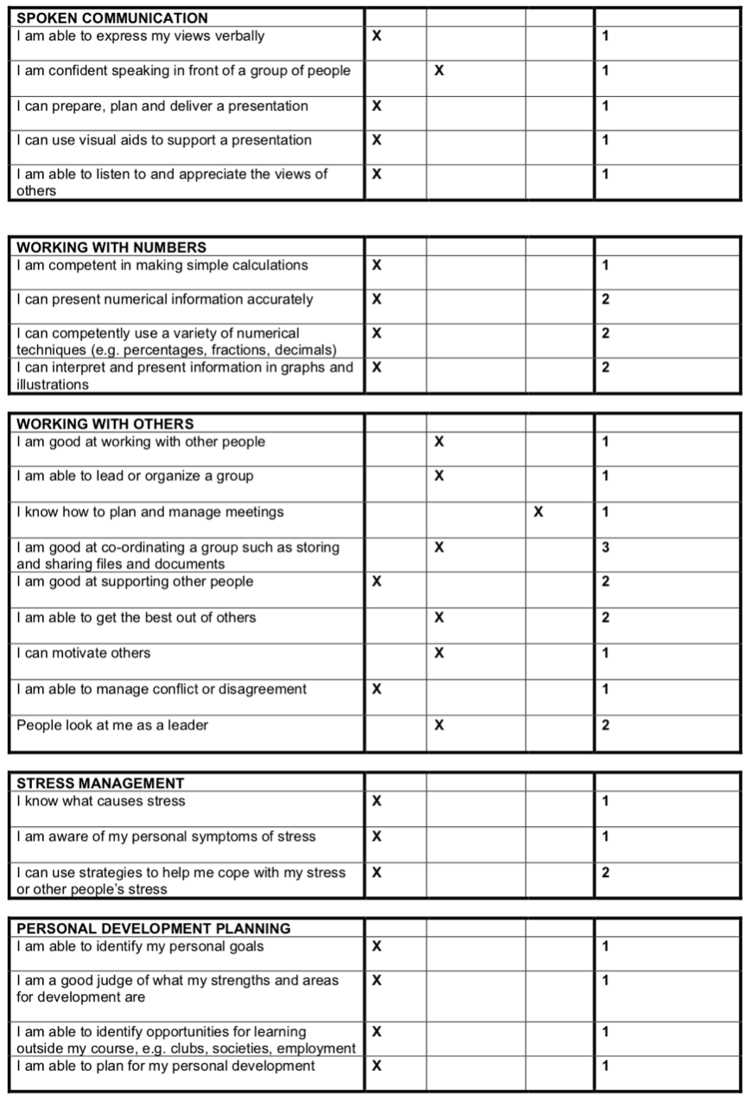

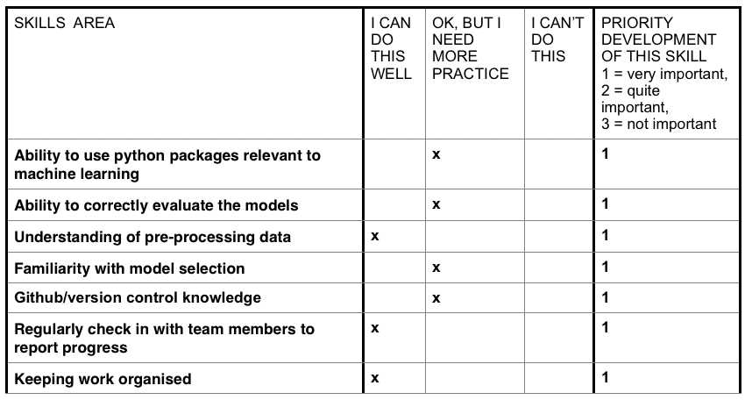**PART 2**

1. **Risk Analysis**

* Risk estimation and evaluation:

Impact categories:

* Negligible (1-2)
* Marginal (3-5)
* Critical (6-8)
* Catastrophic (9-10)

Likelihood of occurrence:

* Always (10)
* Very probable (7-9)
* Probable (5-6)
* Unlikely (2-4)
* Never (1)

Values in brackets: 1(low) - 10 (high)

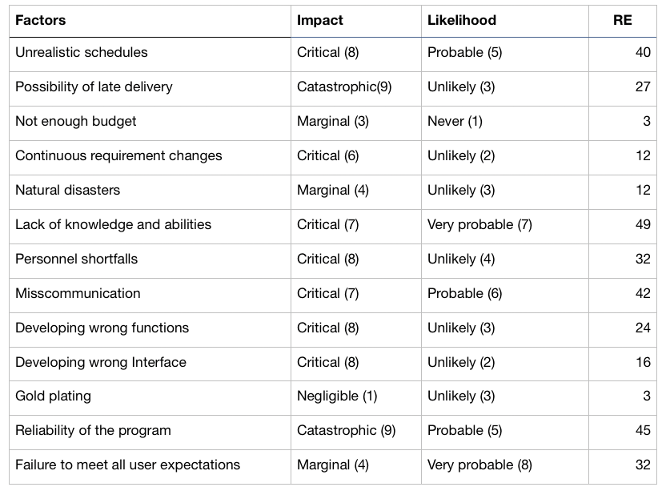Risk Exposure (**RE**) = (**likelihood** of risk occurring) x (**impact** of risk occurrence)

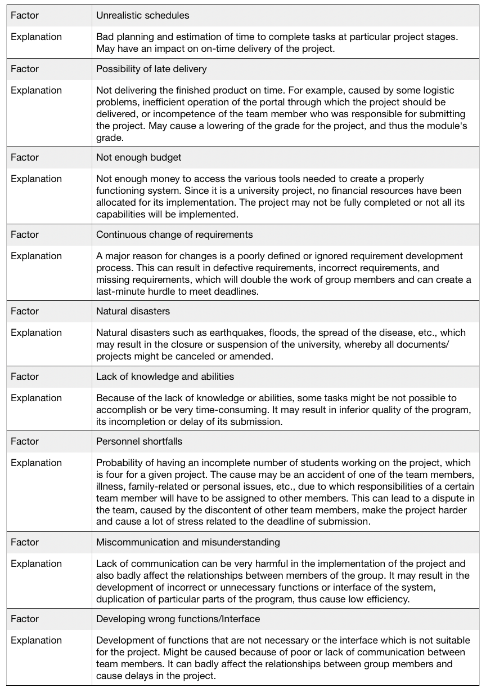

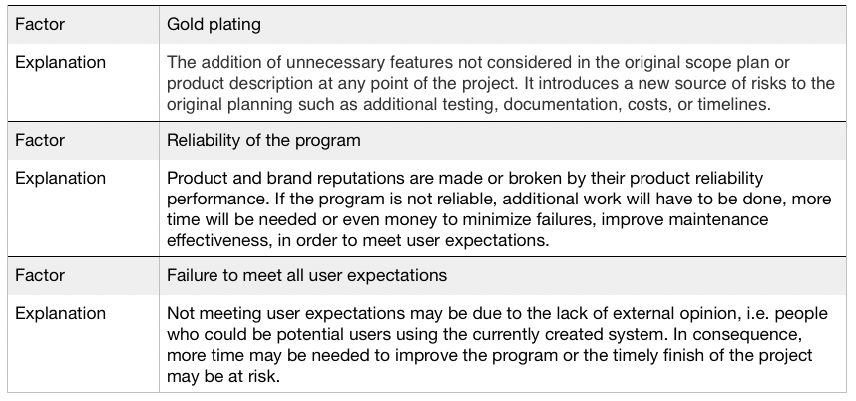

1. **Task Management**

* Problem to be solved

The artificial intelligence ​​problem chosen by our team that needs to be solved using machine learning methods and tools is the classification of text. The project is carried out as part of the Module Assessment in Software Engineering Practice (KF5012) at Northumbria University.

The main idea of our project is to train a model to determine a genre of a body of text out of a dataset. The task will focus on identifying words and phrases that are often associated with particular genres to make a categorization of the genre of the movie. The data used to train the model come from databases containing movie plots and film genres.

* Project strategy

**Communication**

The main tool to communicate with other team members by using group chat, make audio and video calls, is the online application „Messenger”. Beside, the group will be meeting face to face informally during the workshops as well as formally in the group meetings.

**Meetings**

Until the spring break, the meetings will take place every Tuesday at 11 am before the module workshops, so that having any problems or questions there would be a possibility to discuss them with the tutor. During the spring break, meetings will be organized depending on the urgency and availability of the team members either face to face or through the Messenger.

Each meeting will be documented using a template to prepare a short report on the proceedings.

**File sharing/collaboration methods**

All documents and files related and necessary during the execution of the project will be exchanged using a repository hosting service - GitHub. Moreover, for the project development in the Python language, the Spyder environment will be used.

**Allocation of Missions**

Each member of the group will be assigned two individual missions, and there will be one mission for which all team members will be responsible. Individual missions will be allocated taking into account skills audits and the willingness of each team member to undertake to work on the particular missions.

* High level Work Breakdown Structure (WBS)

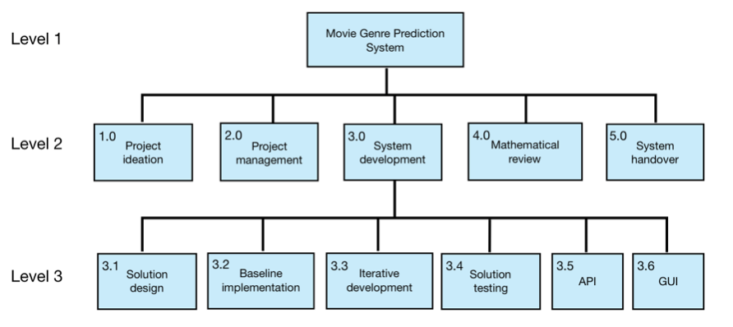

* Low level task breakdown

1. Project Ideation

* Problem Statement
* Problem Motivation
* Literature Review
* Project Outline

1. Solution Design

* Solution Diagram
* Solution Description
* Dataset Description
* Solution Reasoning

1. Baseline Implementation

* Baseline Pipeline
* Baseline Solution
* Baseline Evaluation
* Environment Setup

1. Iterative development

* Pipeline Evaluations
* Model Evaluations and Comparisons
* Parameter Explanations
* Reproducible Code

1. Solution testing

* Test Plan
* Test Cases
* Test Report
* Recommendations based on results

1. Application Programming Interface (API)

* API Design and Justifications
* Explanation of Model Preparation
* Server Setup Explanation
* User Testing

1. Graphical User Interface (GUI)

* GUI Design and Justifications
* Model Integration with the API
* User Testing

1. Mathematical Review

* Mathematical Problem Formulation
* Mathematical Solution Justification
* Mathematical Parameter Justification

1. Project Management

* Code of Conduct
* Team Skills Audits
* Risk Analysis
* Task Management
* Master Schedule
* Progress Report
* Duration, resourcing, and costs

The trim deadline for the project handover was specified for May 11th. The duration of each task, its start week, and the week in which it should be completed are specified on the Gantt chart.

Resources used to help while working on the project are material realized during lectures and workshops, electronic resources such as on-line databases, electronic journals, etc., and any libraries that can be accessed by team members.

No expenses are predicted to be involved. All programs and tools used for the project implementation are commonly available online and free of charge.

* Staff allocation
* Project Ideation - Radek Jirkovsky
* Solution Design - Christopher Graney-Ward
* Baseline Implementation - Justyna Wachowiak
* Iterative Development - Group mission
* Solution Testing - Michael Anderson
* Project Management - Justyna Wachowiak
* Mathematical Review - Radek Jirkovsky
* Application Programming Interface - Michael Anderson
* Graphical User Interface - Christopher Graney-Ward
* Prioritisation
* Project Ideation - **must have**
* Solution Design - **must have**
* Baseline Implementation - **must have**
* Iterative Development - **must have**
* Solution Testing - **must have**
* Project Management - **must have**
* Additional Data - **could have**
* Mathematical Review - **should have**
* Solution Review - **would have**
* Application Programming Interface - **should have**
* Graphical User Interface - **should have**

1. **Master Schedule**

Due to circumstances such as the extension of the hand-in date of the project proposal and the outbreak of the virus, which resulted in the suspension of the university, the Gantt chart of the group project required minor changes. The primary and later versions are presented below.

* Gantt Chart - version 1
* 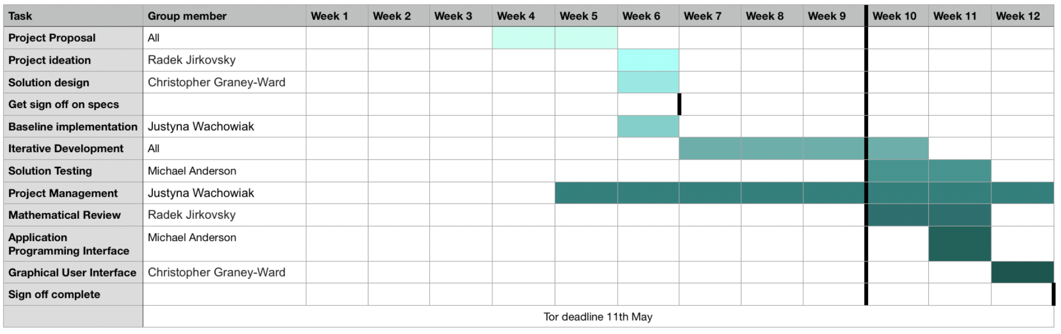Gantt Chart - version 2

A general check of project progress has been planned after weeks 7 and 11. A check of project completeness was planned after week 12.

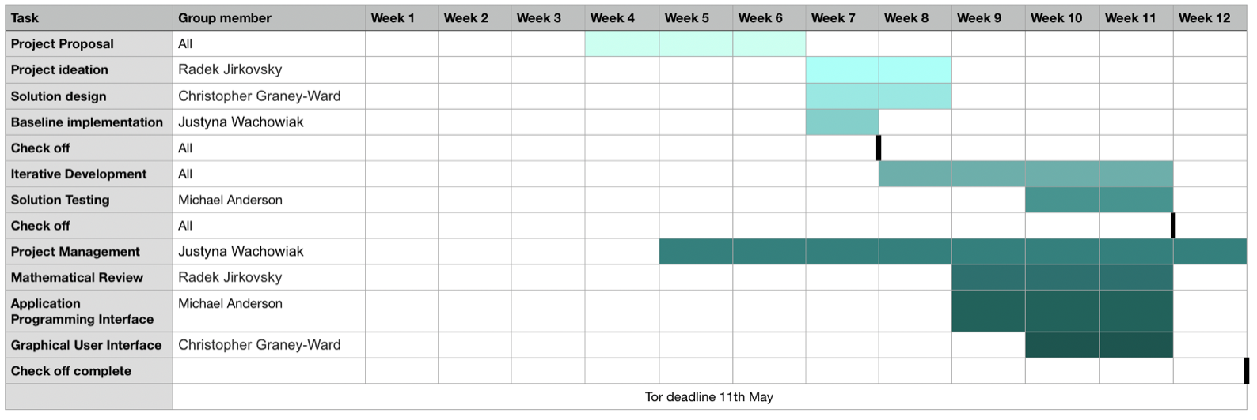

1. **Progress Report**

* Group meeting reports

1st meeting - week 6

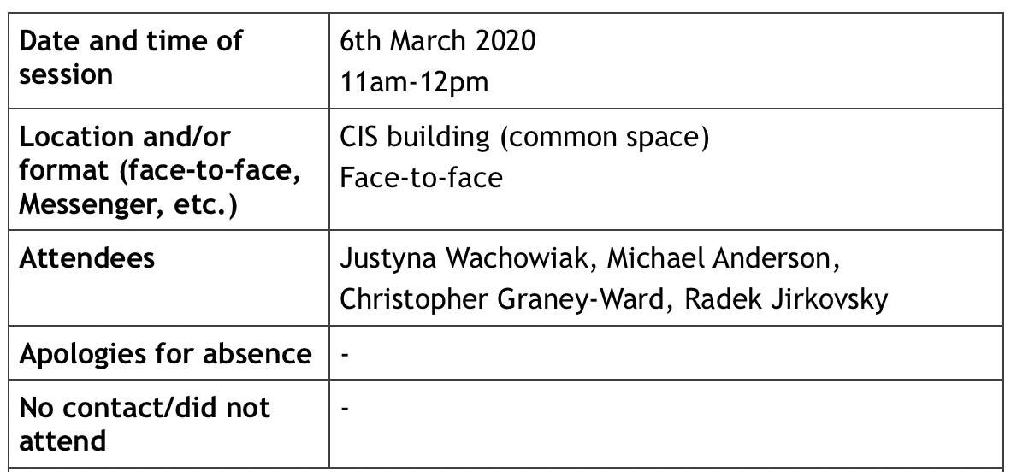

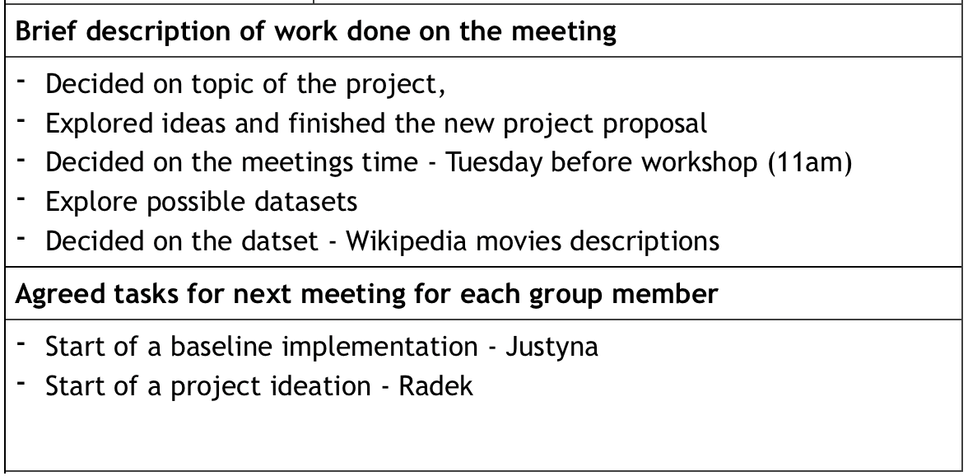

2nd meeting - week 7

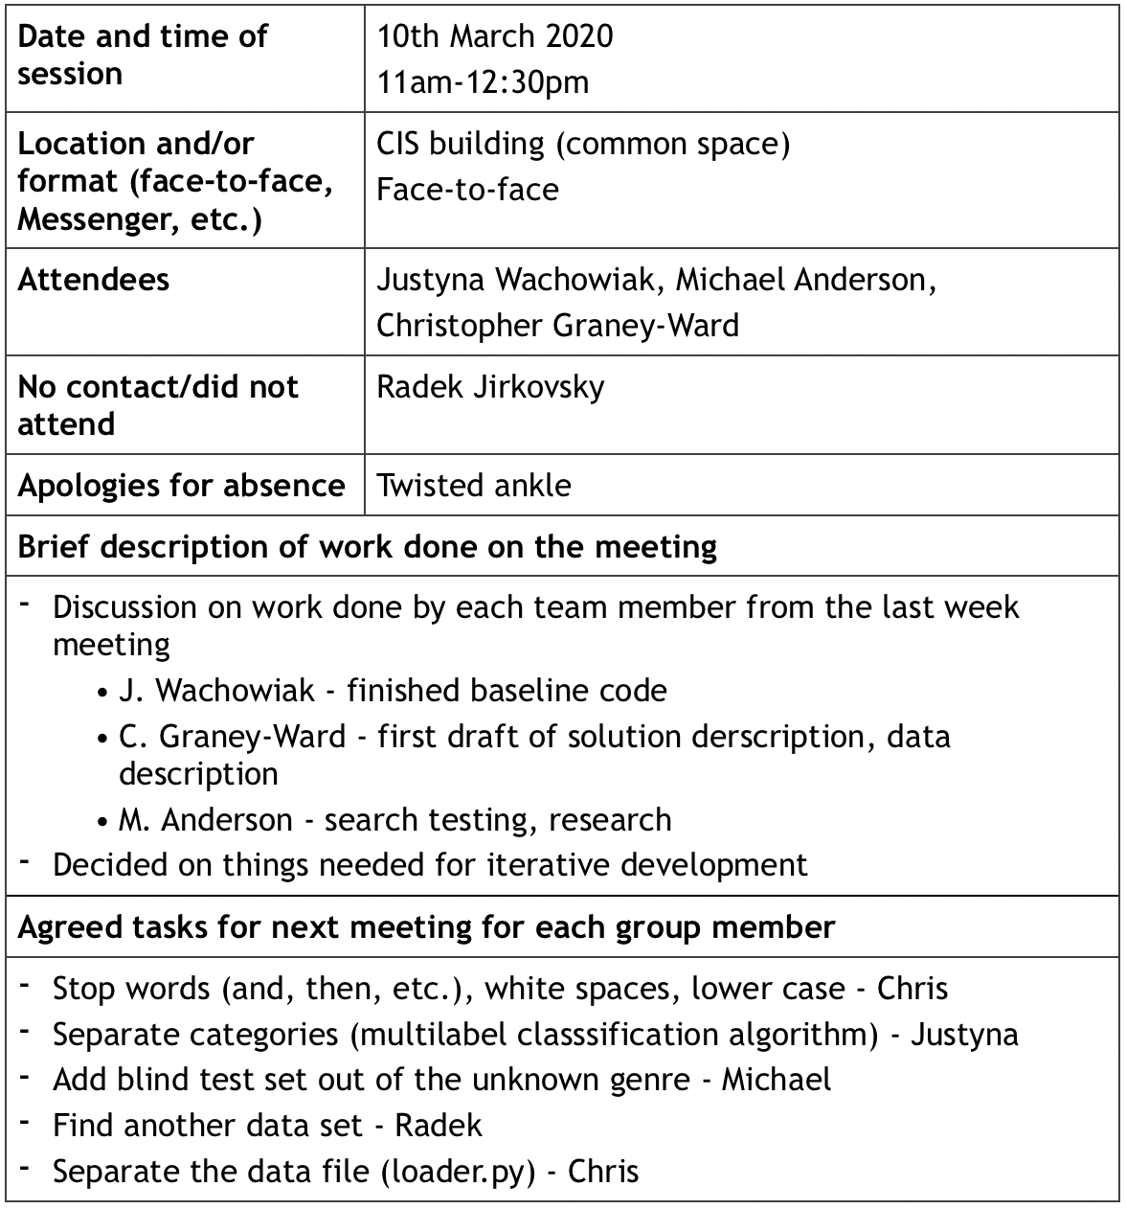

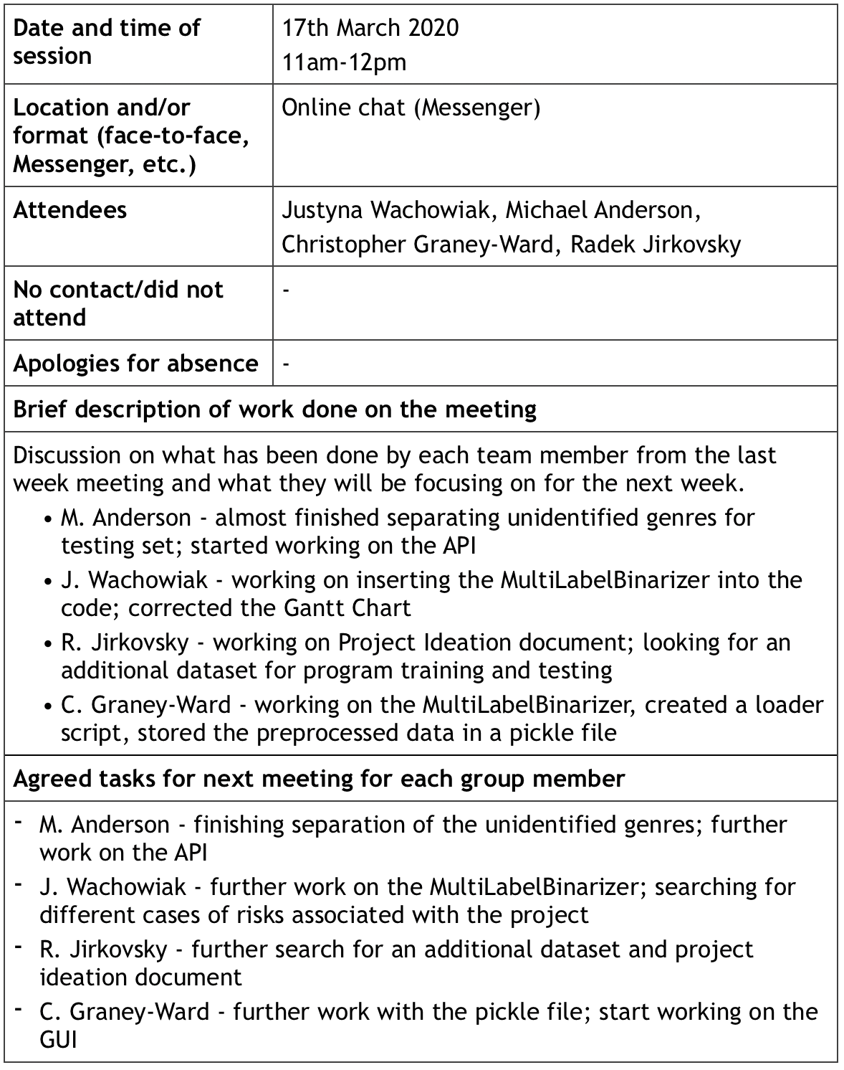3rd meeting - week 8

4th meeting - week 9

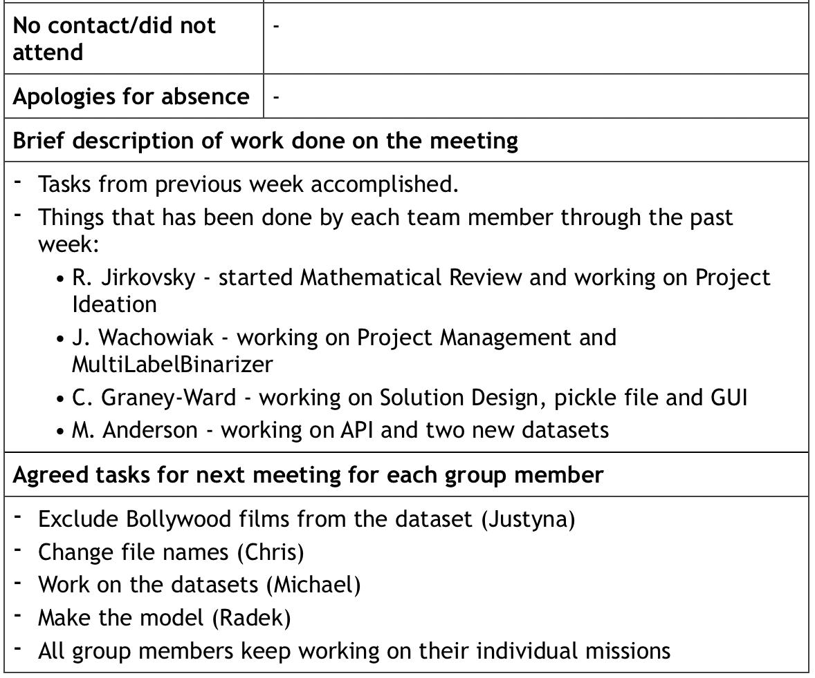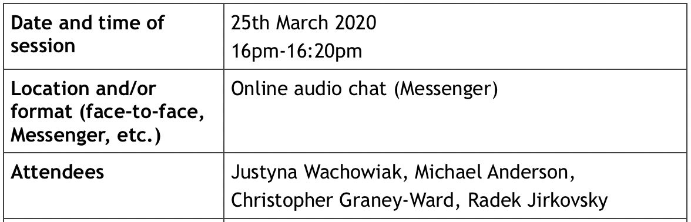

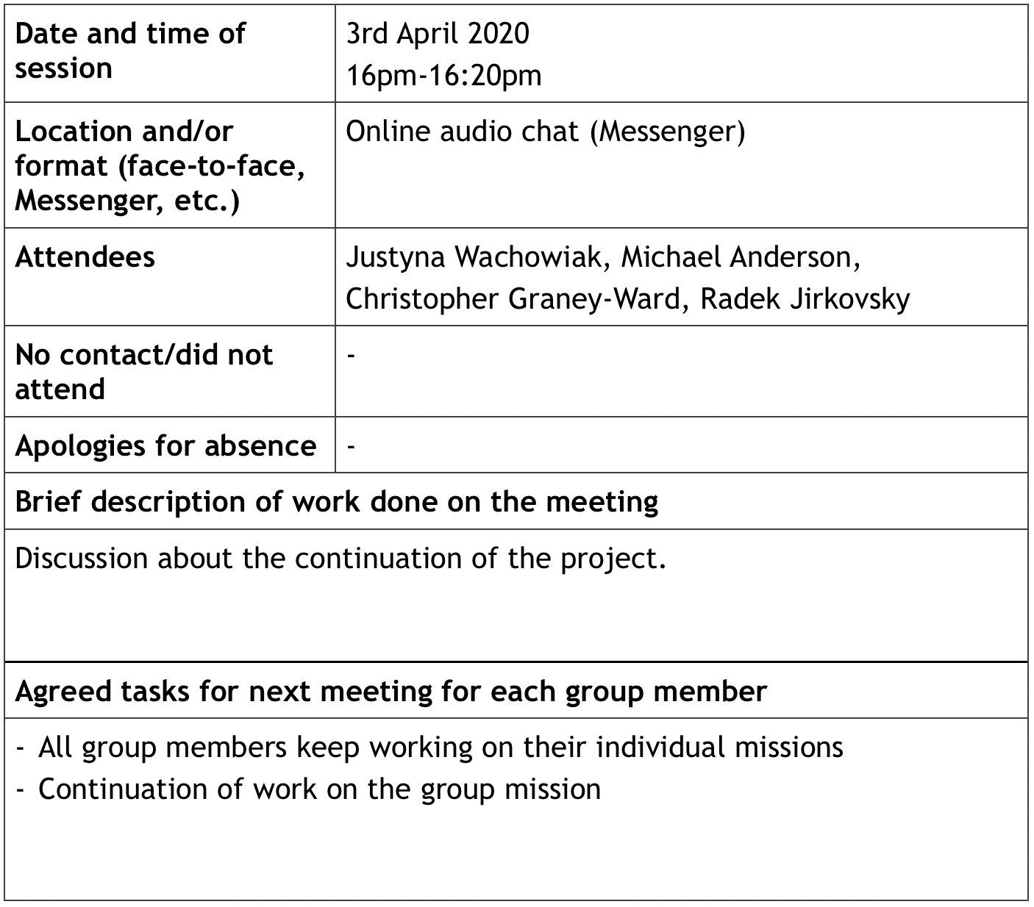5th meeting - spring break

* 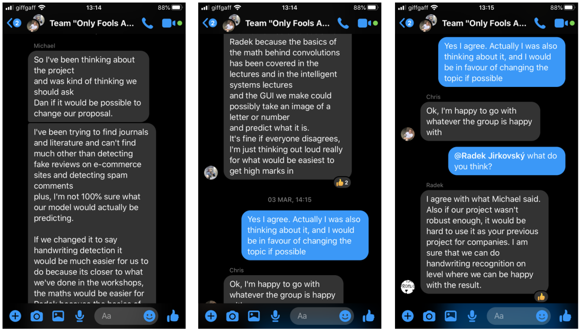Sample group chat screenshots

